**Sheet 11**

Abishek Kumar

Ravikant Tyagi

Erce Can Balcioglu

11.3 (a)

Frequency response

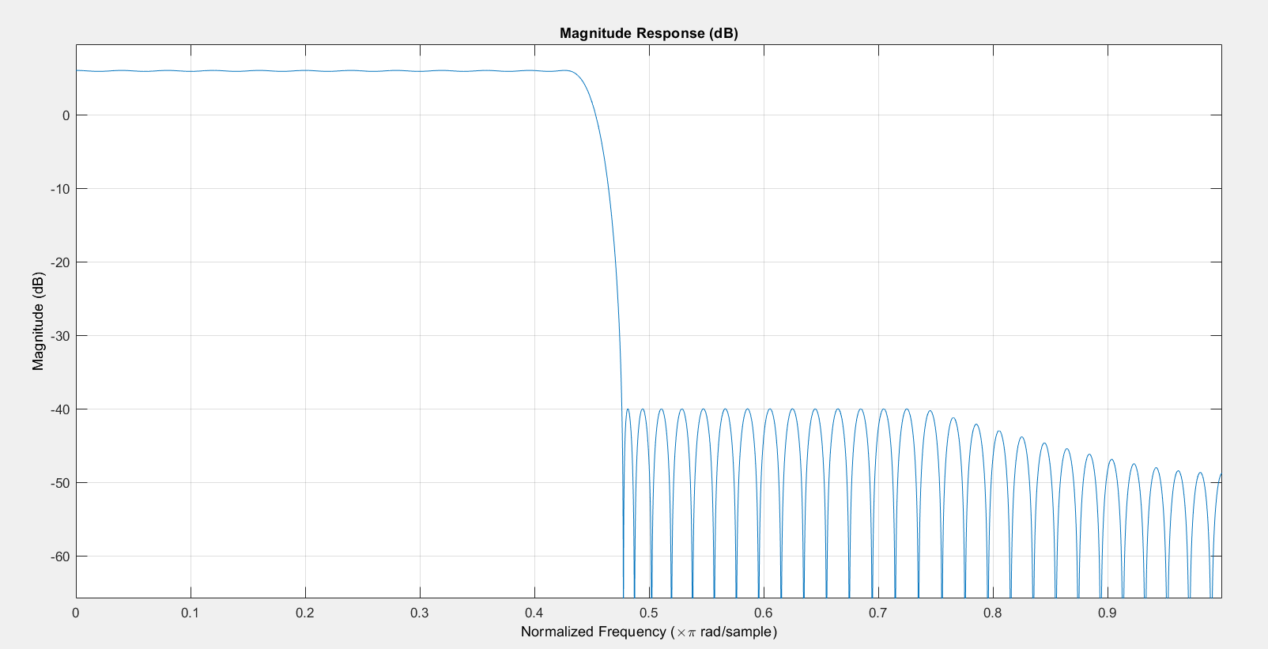

(b)

Order 10

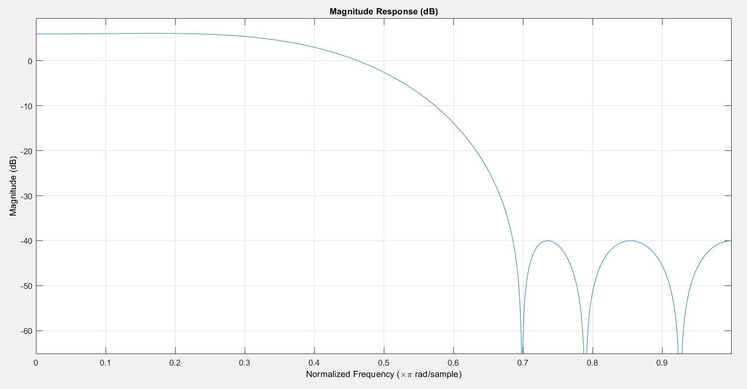

Order 50

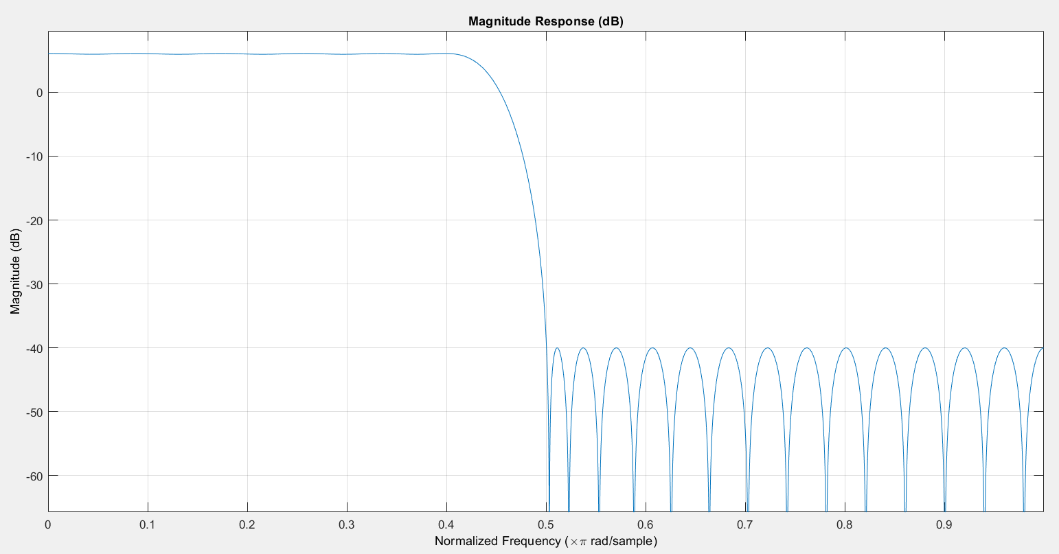

Order 100

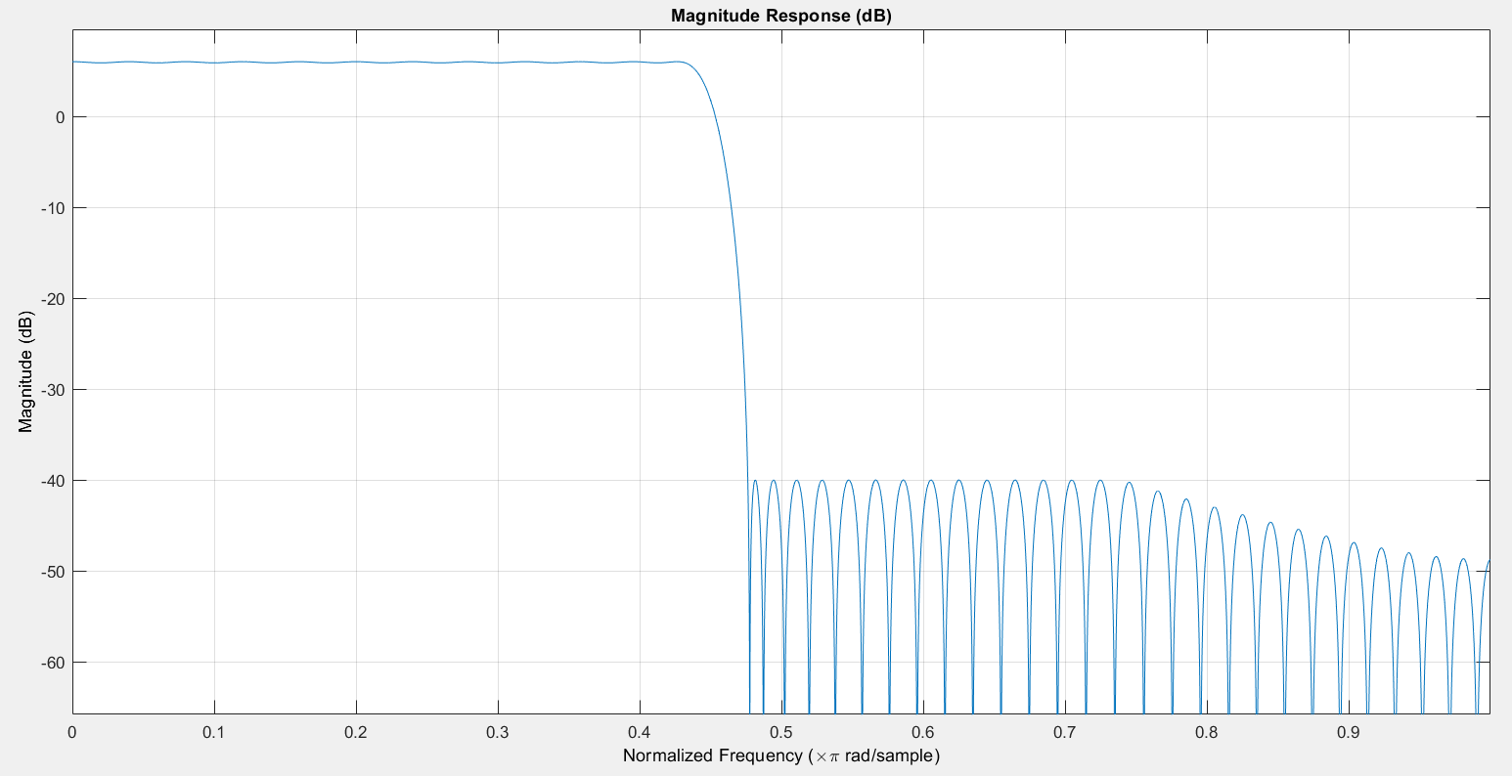

As order increases cutoff will be more precise toward the cutoff frequency.

(c)

Two signal are created and added up in sample.m script